



Love2Shop Mobile Hybrid

Software Requirement Specification

Version: 0.1

May 03 2017

Author: Linh Luu (linh.luuphuong@nashtechglobal.com)

Software Development & Business Process Services

110 Bishopsgate, London

EC2N 4AY

Tel: +44 (0)20 7333 0033

Email: [info@nashtechglobal.com](mailto:info@nashtechglobal.com)



Document History

| Document Version History | | | |
| --- | --- | --- | --- |
| Version | Date | Edited by | Details |
| 0.1 | 4 May 2017 | Linh Luu | Initial Document |
|  |  |  |  |

Approvers

| Distribution List | | | | |
| --- | --- | --- | --- | --- |
| Name | Role | Signature | Date | Version |
| Tony Kennils |  |  |  | 0.1 |
|  |  |  |  |  |

Confidentiality

This document is distributed on a restricted basis, is commercial in confidence to the recipient, and may not be used for any purpose other than that associated with a NashTech project. The contents of this document may not be disclosed to any third parties without the expressed advance written authorisation of NashTech.

# Introduction

## Overview

Park Group is one of the UK’s leading multi-retailer voucher and prepaid gift card business, focused on the corporate gift and Christmas savings markets and sales are generated through the Internet, direct sales force and agents.

Love2Shop (L2S) is the Park Group's leading gift voucher and card, accepted at over 100 major retailers with more than 20,000 stores UK wide. Love2Shop schemes are tailored to individual customer needs, principally recognising and rewarding a range of performance attributes. These include exceptional service, loyalty, making good suggestions, attendance, achieving targets and project completion and are also applicable to a vast range of other possibilities.

Park Group would like to leverage the Love2Shop implementation for mobile business. The core L2S UK site will be integrated to OpenCMS for static content, and to the iSeries system for the product management.

## Purpose

The SRS fully describes the functional requirements and external behaviour of the system. It also covers non-functional requirements, and other factors necessary to provide a complete and comprehensive description of the requirements for the mobile software.

# User Requirements

## Actor

Most users who interact with the L2S application are people who want to buy gift cards and gift vouchers. The following is a list of Actors specific to the L2S system:

| Actor | Description |
| --- | --- |
| Public/ Non-registered user | The person who has a limited access to the features of the L2S Mobile application. Only register an account, view the card balance and check where the card can be spent. |
| Registered user | The person has full permission to access all features of the L2S Mobile application such as manage account info, add a new card, purchase gift/ voucher cards, view special promote cards, etc. |

## Use Case Model

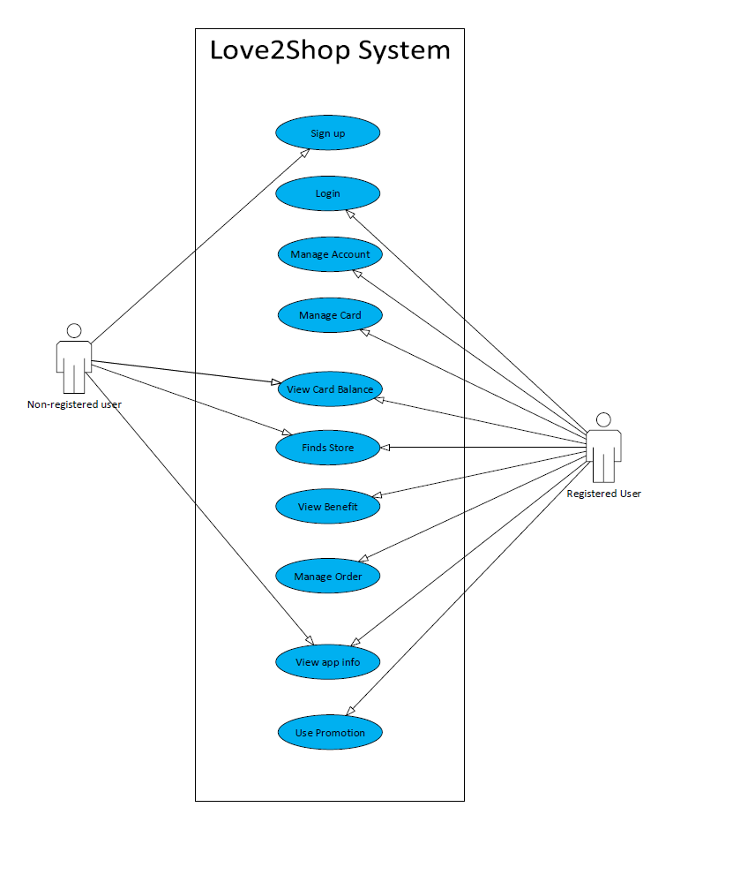

Figure 1: Use Case Package – Love2Shop Management System

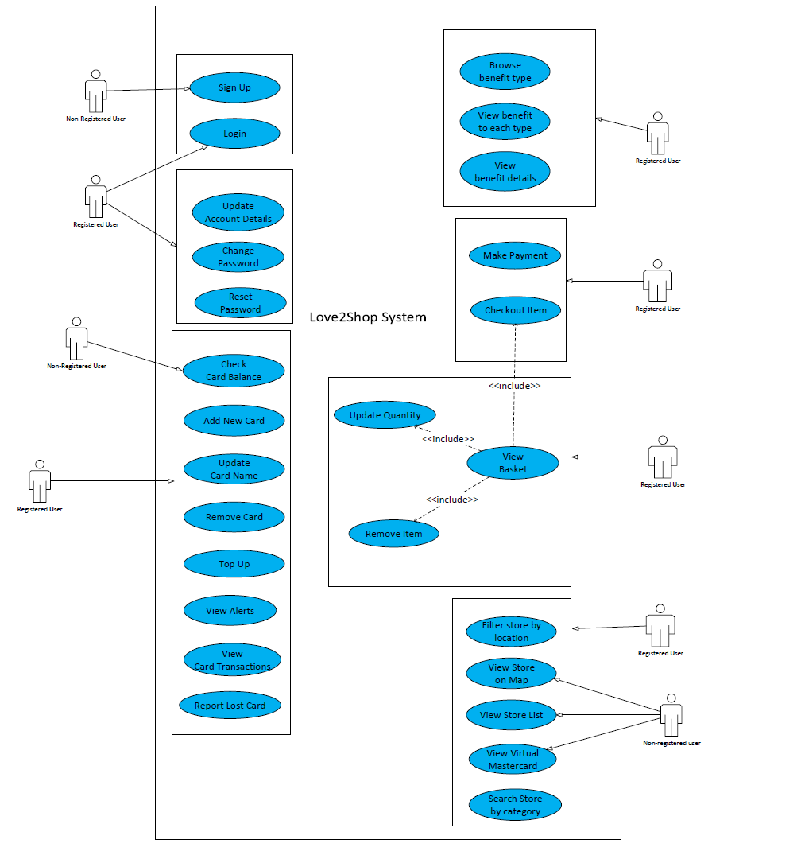

Figure 2: Use Case Diagram – Love2Shop Management System

## Use Case Catalogue

| # | Use Case | Description |
| --- | --- | --- |
| **Application Welcome** | | |
| 1 | Splash screen | A window with logo in the design to notify the user that the program is in the process of loading. |
| 2 | Homepage for public user | Allow the public user to understand the business of the application and limit the access to the features for logged in users like Cards management or Special Offers, etc. |
| 3 | Homepage for registered user | It allows registered users to view the card with savings amount, balance amount, special offer, etc. |
| **Account Management** | | |
| 4 | Sign up | It allows the user to register/ create an account to get full access to L2S app such as view cards/ codes, get access to exclusive offers, etc. |
| 5 | Sign in for first time user | At the first time login, the user needs to enter 5 digits PIN then create the touch ID in case users want to sign in by thumb print ID. |
| 6 | Sign in for returning user with PIN | Provide a screen for the user log in with 5 digits PIN. |
| 7 | Sign in for returning user with Touch ID | Provide a screen for the user log in with a thumb print ID. |
| 8 | Change password | Allow the user changes the password |
| 9 | Update personal details | To update account details with personal information. |
| 10 | Reset password | Allow the user resets password |
| **Benefit Management** | | |
| 11 | List of benefits according to each type | Provide a list of benefits depending on the type of benefits selected. |
| 12 | View benefit details | Show detailed information about the benefits that users enjoy. |
| **Financial control** | | |
| 13 | Add card | A place where the user can add a new card to wallet. |
| 14 | View wallet | To store all the current cards in the wallet |
| 15 | Update card name | To update the name of card in use. |
| 16 | Remove card | To remove the current card from the card wallet. |
| 17 | Top up | Allows the user to specify the amount you wish to change for your card. This feature is applied to Flexecash card/ e-voucher only. |
| 18 | View alerts | To set the alert setting to notify the information of the card through the mobile phone number entered.  This feature is applied to Flexecash card/ e-voucher only. |
| 19 | View transaction with card | Show the history of the transactions for the card that was purchased such as total amount spent and purchased date. |
| 20 | Report lost or stolen | To report the card as lost or stolen then the customer service will arrange a replacement card. |
| 21 | Check balance | To get the current balance on your card when prompts the digit card security code shown on the back. |
| **Order Management** | | |
| 22 | Check out | It is a process of ordering from beginning to the end until the goods are ordered successfully. |
| 23 | Process Payment | It is a process that allows users a payment for purchased items by credit/ debit card. |
| **Promotion** | | |
| 24 | View special offer in the homepage of registered user | To manage promotions for the registered user. It may have the impact on the order and the transaction records. |
| **Store** | | |
| 25 | View stores on map, list | A map that locates areas of shopping store where Love2shop cards can be spent.  Show a list of shopping store in the form of list. |
| 26 | Filter user location | To show stores in preferred location |
| 27 | View list of Virtual Mastercard | To show a list of online shopping stores only. |
| 28 | Filter stores by category | To allow the user shows stores by selecting categories can be paid by Love2shop card. |
| **App Info** | | |
| 29 | Where to spend | Show a list of places where Love2shop products can be spent. |
| 30 | About us | Some brief description to introduces to the company and services provided of Love2shop |
| 31 | Term & conditions | Provide term and condition for the card in use. |
| 32 | Help | Some brief description describes how to purchase cards using current card, etc. |

# Functional Requirements

The list of requirements can be occurred by the user’s actions but are not covered adequately by the user requirements in section 2.

The detailed note may be available for specific use case. For example, how to handle the interrupts for some special cases will need to be mentioned in the use case.

| # | Functional Requirements | Description |
| --- | --- | --- |
| 1 | Application installation program | The user will need to install the mobile application via App Store or Google Play when launched. |
| 2 | Application launch | The user must be able to view the splash screen while loading the application. |
| 3 | Interrupts, notifications | When a phone call, SMS or some type of notification (such as a calendar notification) arrives, the mobile device will usually inform the application of this event. If the user chooses to respond to the event, the application must handle to such action depending on the situation:   * Background the application * Terminate the event   In the general case, the system will need to capture the current state that the user viewed before the interruption. For any special case like payment processing, the use case will specify where the application will resume. |
| 4 | Network protocol transition | The most common scenario is to change the connection from Wifi to 3G, the application will need to resume the current state 3 times, each time 5 seconds and trigger the data loading/ submission within such time range.  The user may be able to see the loading screen with the message “Resetting your connection,,”.  However, this behaviour will not be applicable for any third party |
| 5 | Signal drop – Lost connection | In the general case, the application will terminate its event and request the user to either:   * View the homepage for public user * Enter the PIN code of the user account then show the homepage for registered user |

# Non-functional Requirements

## User Interface

* The design must follow the layout specified in the provided prototype
* All of the content of the application must be managed conveniently for the future changes.
* The application does not support Landscape mode for mobile
* Ionic UI component is close to iOS style.
* The prototype has been designed for iOS native application while we use PhoneGap as the technology to build the mobile application with some limitations
  + The bottom menu will be on top of the screen in Android.

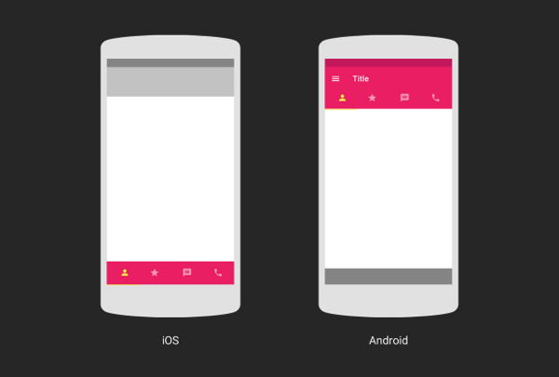

* + No Back button on top-left in Android (using hardware back button).

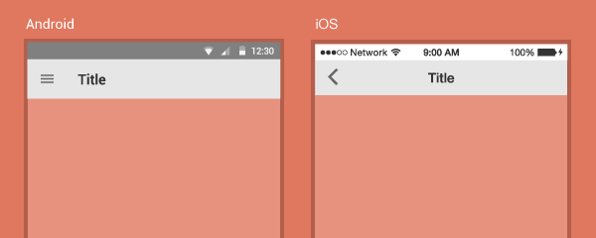

* + Action sheet, Date Time dialog will display from bottom (iOS style).

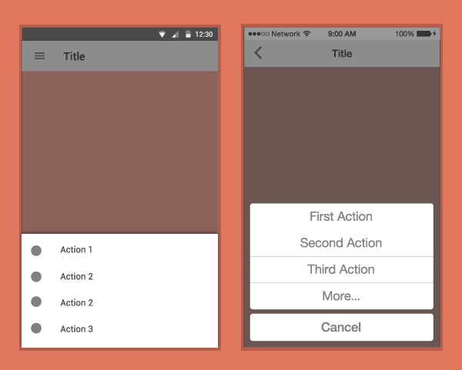

* + Segment style is difference between iOS and Android.

## External Interfaces

### Flexecard Payment

Followed the client’s business, each user will receive a physic card and add the information of this card to use for each virtual account.

Therefore, the system will need to integrate to:

* Add the Flexecard
* Process payment with Flexecard
* Navigate the user to input any required information for the payment

### Common Card Payment

## Multi-Language

The application will have English only but it will be designed and implemented to support multiple languages.

## Performance

The application needs to guarantee the loading time between screens does not take too long. The ideal time to switch screens is 15 seconds by default.

## Security

Advanced Encryption Standard (AES) is recommended for the purpose of data confidentiality.

## Audit

The audit activities should be processed and handled by Park Group.

## Timing and Dependencies

Prior to the development, Park Group will:

* Review and finalize the Q&A, wireframes
* Approve the specifications and all the related use cases
* Provide the required hosting environment for all web based interfaces of the application.
* Provide the design and style guide for mobile and tablet, at least to start developing the features for the first 2 sprints.
* Provide the mid-tier web services, at least to start developing the features for the first 2 sprints.

Prior to the last 2 sprints, Park Group will provide:

* The Content Management System to enable informational screens within the application.

Along with the development, Park Group will:

* Support the Developer in testing the website functionality.